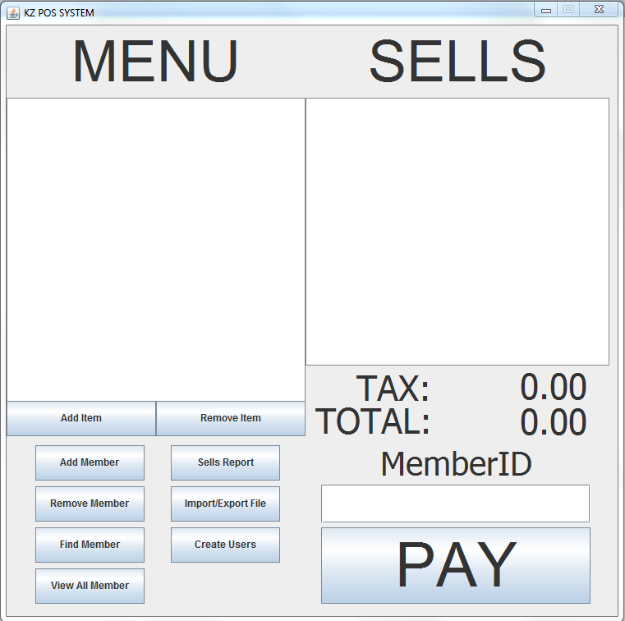

**IMPORTANT NOTES**

* Make sure you don’t have a database called 370project in your MYSQL

**How to make sells**

* Click the item in the menu list and it will be added to the sell’s list. It will calculate the total amount for the user.
* Enter memberid if the customer has a member account or leave it blank if they don’t.
* Click pay after the menu selections are done. The sells will be saved into database as sell’s record for later uses.

**Login**

* Use default admin **root** and default password **root** to login into the application

**Add Item**

* Prompts the user to add item into the menu so you can click the item and it will be display in the sells list on the right.
* Must have an admin account in order to add in the items.
* Will prompt user to enter the item name and cost for adding.

**Remove Item**

* Click the item on the list and click remove to get it remove from the menu.
* Must have an admin account in order to remove the item.

**Add Member**

* Create a new member account for the customer for them to get reward points for the store.
* All information must be filled up in order to create member.
* Must have an admin account in order to create member.

**Remove member**

* Remove the member from the database.
* Must have the membered and an admin account in order to remove the member

**Find member**

* You can find the member information by memberid, first name or last name. it will display the member information in a table

**View All Member**

* Display all the members in the current database in a table with all the information

**Sells Report**

* Display the sells record either by daily, monthly, or yearly in a table

**Import/Export**

* Import – imports a text file in the right format and add the members into the member table in MYSQL database.
* Export – will export the member table from MYSQL database into a text file and save it in the directory folder with the same format as input.

**Create User**

* You can create additional users to have access to the application
* You have the option to make it admin or just normal account.
* Must have an admin account in order to make accounts.